Happy New Year! We are excited to get this 2019 Tax Year started, how about you?  There weren’t a lot of changes this year so not a lot of updates for everyone.  The first major change is NO HEALTH INSURANCE PENALTY!!  But remember, if you get assistance through the Marketplace with your insurance, you will receive a 1095-A and you MUST file on that in order to receive your health insurance for the next year.  The Child Tax Credit remains at $2000 per dependent up to the age of 16. And $500 for other dependents living in the home.  Contact Us  Phone: 606.523.9700  Email: jenny@mitchellacctg.com  Web: mitchellacctg.com |  |  | Mitchell Tax & Accounting  8828 KY 1232  Corbin KY 40701 |  |  | Mitchell Tax & Accounting  - 606.523.9700

Standard Deduction  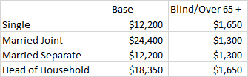  Head of Household Audits  To be considered Head of Household…  - Must be unmarried as of last day of year, or have NOT lived with spouse for last 6 months of year  - Must be a US citizen or resident  - Must pay over half of the cost of maintaining his/her home – and have proof  - Qualifying person must live in the home, except a parent  Tax Time Office Hours  Monday – Friday 8am – 6pm  Saturdays 10am – 2pm  Other times may be available by appointment only! |  |  | Qualifying Child for Child Tax Credit  - Claimed as your dependent  - Under the age of 17  - Your – son, daughter, adopted child, stepchild, brother, sister, stepsibling or foster child (placed in your home by authorized agency)  The PATH Act is delaying refunds till after February 15th for Earned Income Credit and Additional Child Tax Credit filers.  Self-Employed Income  The IRS is recommending a separate bank account for businesses. They are auditing more and more for the Earned Income Credit. So be sure to have proof of income and include ALL expenses!  Need a copy of your tax return:  No problem! We still have our Secure File Portal. You can get copies of your previous or current tax returns securely. You can also submit your tax information to us through the portal and save a trip into our office. All we need is your email to get you started. |  |  | 2019 Income Tax Rates  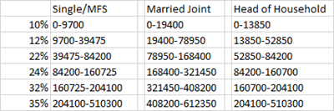  What to Bring  W2’s & 1099’s  Social Security Statements  1095-A Insurance Papers  IRA Distributions/Rollovers  1098-T for College Tuition Paid  Student Loan Interest  Driver’s License  New Dependents – Social Security Cards  Dividend/Investment Year End Statements  Mortgage Interest Statements  Property Taxes  Church/Charity  BUSINESS CLIENTS – WHAT TO BRING  Year End Inventory  Year End Loan Balances and Interest Paid  New Equipment Purchased  Business Mileage/Nights Away from home

